Lab 1 - Measure Your Heart Rate
Group Number: ____ Date: ____
Group Members (co-authors): 1) __________ 2) __________ 3) __________
Co-author roles (rotate weekly): Data Collection - ____ | Analysis/Calculations - ____ | Documentation/Screenshots - ____. Each member contributed equally.

Workflow - do this for every graph (read first)
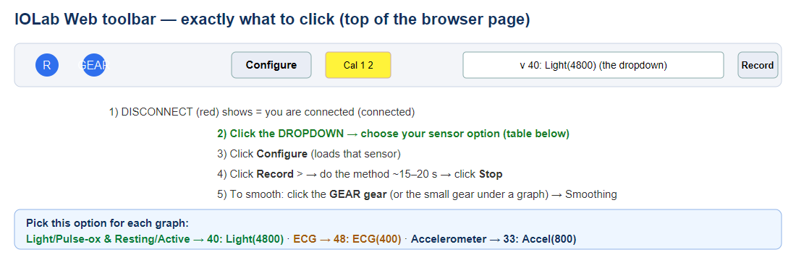
- Confirm the device is connected: the button at the top says DISCONNECT (red). Cal box is yellow.
- Click the DROPDOWN and choose the sensor option for the graph you are doing (exact option listed in each section below).
- Click Configure. This loads that sensor.
- Get into position for the method (wiring or finger/chest placement - see each section).
- Click Record. Collect for about 15-20 seconds while staying still. Click Stop.
- Zoom in until you can see about 5-10 beats. Use the Highlight tool: click-drag across several consecutive beats. The pop-up box shows the average (mu) and the TIME SPAN of your selection.
- If the signal is noisy (ECG or accelerometer): click the gear menu and turn on Smoothing (ECG = 25), then re-highlight.
- Write down the interval (seconds) of your selection and count the beats inside it.
- Open Lab1_BPM_Calculator.xlsx. Type the beats and interval into the yellow cells for that measurement - the BPM fills in automatically.
- Take a screenshot: press Windows + Shift + S, drag across just the graph, and paste it into the matching placeholder below. Do NOT use a phone photo.
- Copy the BPM into the blanks under that graph and into the Heart Rate Summary table.

IOLab Web setup (Chrome - no install)
- Put 2 AA batteries in the IOLab and slide the power switch ON.
- Plug the USB dongle into the laptop.
- In Google Chrome, go to iolab.science/iolabweb .
- Click Connect. When Chrome asks, select the IOLab dongle and click Allow. The top button changes to DISCONNECT (red) = connected.
- If it does not find the device: turn the IOLab OFF, hold the + button while turning it back ON (Discovery Mode), then click Pair.
- If it asks to calibrate, click Configure once with the Cal box; otherwise you are ready.

Purpose / Hypothesis
Purpose: Use the IOLab to measure heart rate three different ways - a rudimentary ECG (high-gain electrical input), a pulse oximeter (light sensor), and the built-in accelerometer - and compare resting vs active heart rate. This shows that one biological process (the heartbeat) can be measured through three different physical quantities: electrical, optical, and mechanical.
Hypothesis: All three sensors will show a periodic heartbeat. The light-sensor (optical) method will give the clearest signal because pulsing blood strongly changes how much light passes through the fingertip. Heart rate will increase noticeably from resting to active.

Data & Graphs

Graph 1 - Pulse Oximeter (Light sensor) [do this first - easiest]
Dropdown option: 40: Light(4800) (or 6: Light(400)). Configure -> Record.
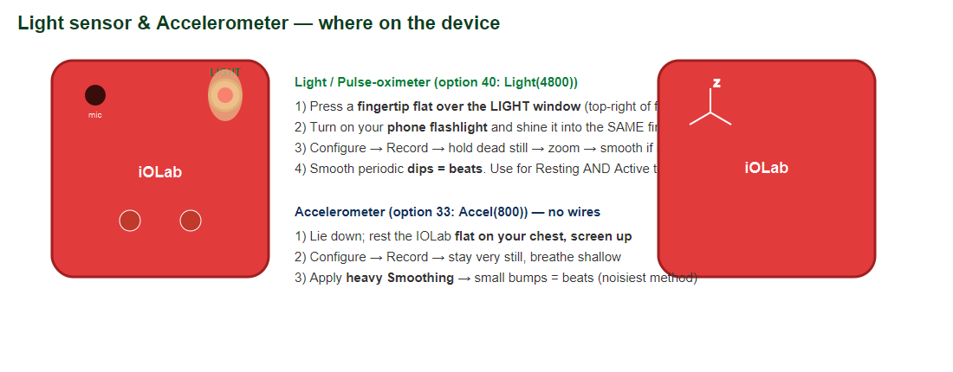
Placement (exact):
- Turn on your phone flashlight.
- Press a fingertip flat over the LIGHT sensor window (small round window, top-right of the front face).
- Shine the phone flashlight into that same finger from the other side.
- Hold dead still. Zoom in; if wobbly, gear menu -> Smoothing.
Real example to match:
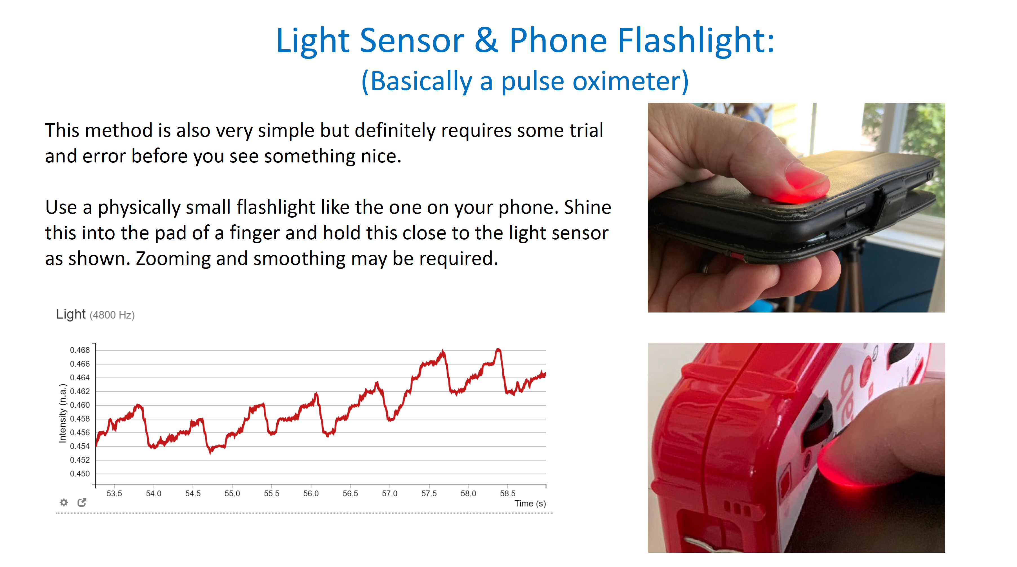
[ PASTE SCREENSHOT #1 HERE - Light sensor graph, several beats highlighted, cropped to the graph ]
Graph 1 - Pulse Oximeter (Light). Highlighted ___ beats over ___ s. -> Interval ___ s, Beats ___, BPM = beats/interval x 60 = ___
What it should look like: a smooth wave with evenly spaced dips - each dip is one heartbeat.

Graph 2 - ECG (High-Gain electrical input)
Dropdown option: 48: ECG(400). Configure -> Record -> Smoothing = 25.
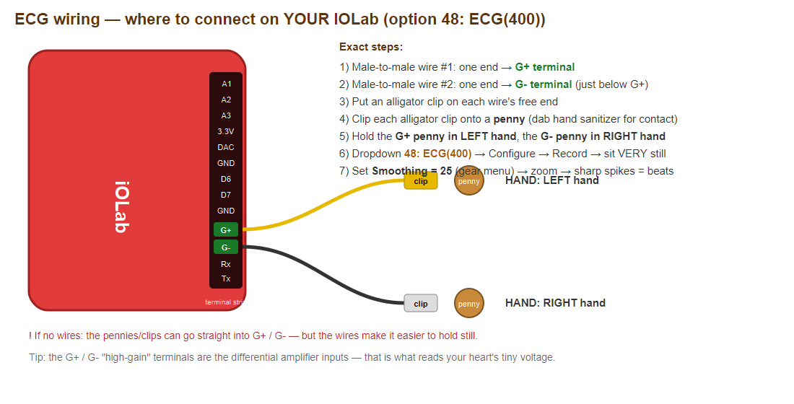
Wiring (exact - see diagram):
- Male-to-male wire #1: plug one end into the G+ terminal on the right-edge terminal strip.
- Male-to-male wire #2: plug one end into the G- terminal (directly below G+).
- Clip an alligator clip onto the free end of each wire.
- Clip each alligator clip onto a penny (dab hand sanitizer on the pennies for good skin contact).
- Hold the G+ penny in your LEFT hand and the G- penny in your RIGHT hand. Sit very still, arms relaxed.
- Set Smoothing = 25 (gear menu), then zoom.
Real example to match:
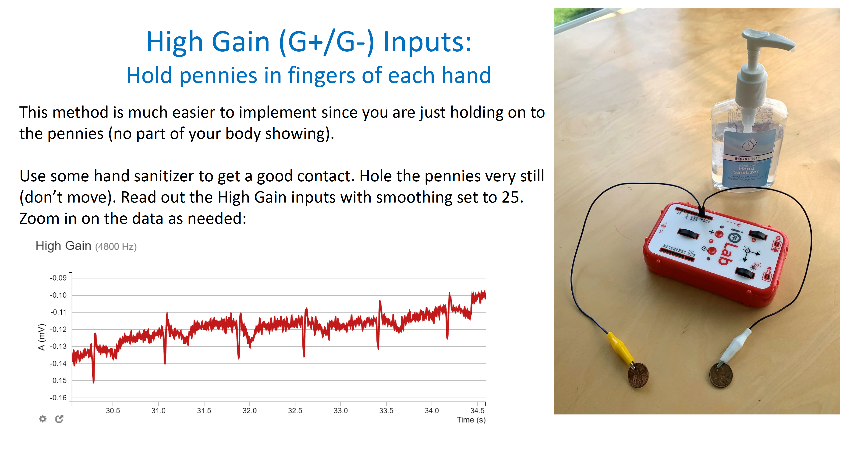
[ PASTE SCREENSHOT #2 HERE - ECG (High Gain) graph, several beats highlighted, cropped ]
Graph 2 - ECG (High-Gain). Highlighted ___ beats over ___ s. -> Interval ___ s, Beats ___, BPM = ___
What it should look like: sharp, evenly spaced spikes - one spike per heartbeat.

Graph 3 - Accelerometer
Dropdown option: 33: Accel(800) (or 2: Accel(400)). Configure -> Record.
Placement (exact): no wires. Lie down and rest the IOLab FLAT on your chest, screen facing up. Stay very still and breathe shallow. Apply heavy Smoothing (gear menu).
[ PASTE SCREENSHOT #3 HERE - Accelerometer graph (smoothed), several beats highlighted, cropped ]
Graph 3 - Accelerometer. Highlighted ___ beats over ___ s. -> Interval ___ s, Beats ___, BPM = ___
What it should look like: small, evenly spaced bumps in the smoothed trace - one bump per heartbeat. (Noisiest method.)
Real example to match:
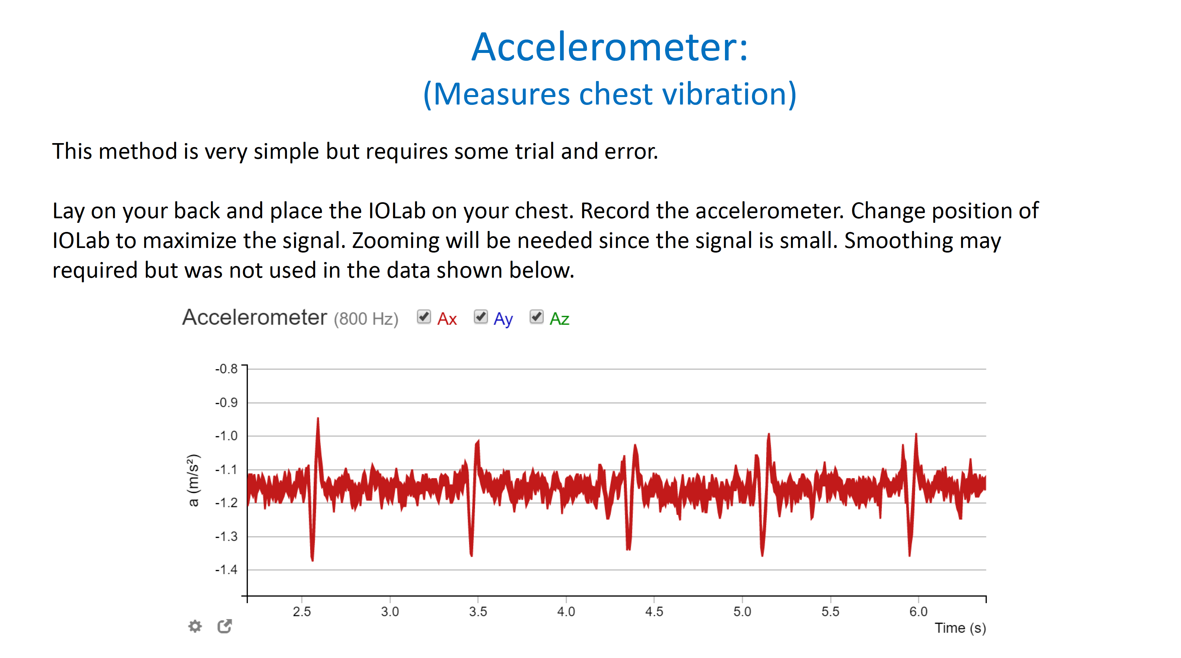

Graph 4 - Resting Heart Rate (Light sensor)
Dropdown option: 40: Light(4800). Same finger + flashlight setup as Graph 1, while sitting calm and relaxed. Configure -> Record.
[ PASTE SCREENSHOT #4 HERE - Resting HR (light sensor), several beats highlighted, cropped ]
Graph 4 - Resting HR. Highlighted ___ beats over ___ s. -> Interval ___ s, Beats ___, BPM = ___
What it should look like: evenly spaced dips relatively FAR apart (slower rate).

Graph 5 - Active Heart Rate (Light sensor, after exercise)
Dropdown option: 40: Light(4800). Do about 30 seconds of jumping jacks, then IMMEDIATELY set up the finger + flashlight and Record.
[ PASTE SCREENSHOT #5 HERE - Active HR (light sensor), several beats highlighted, cropped ]
Graph 5 - Active HR. Highlighted ___ beats over ___ s. -> Interval ___ s, Beats ___, BPM = ___
What it should look like: the same dip shape as Graph 4 but spaced CLOSER together (faster rate).

Heart Rate Summary
Measurement | Beats | Interval (s) | BPM | Expected range | Notes
ECG (High-Gain) |  |  |  | 60-100 (resting)
Pulse Oximeter (Light) |  |  |  | 60-100 (resting)
Accelerometer |  |  |  | 60-100 (resting)
Resting HR |  |  |  | 60-100 (resting)
Active HR |  |  |  | 100-170

Analysis & Discussion (Reflection)
What physical quantity was each sensor measuring?
ECG (high-gain) measured the small ELECTRICAL voltage produced by the heart. The light sensor measured LIGHT intensity, which changes as blood pulses through the fingertip (photoplethysmography). The accelerometer measured ACCELERATION - the tiny mechanical motion of the body caused by the heart pumping.
Which method produced the clearest signal?
The optical (light sensor) method produced the clearest, most periodic signal, because pulsing blood strongly changes the transmitted light. [Adjust to match your actual results.]
Which method was most sensitive to noise?
The accelerometer (any body movement adds noise); the high-gain ECG was also noisy from electrical interference, so smoothing (25) was needed.
Why do smartwatches typically use optical sensors rather than accelerometers or ECG leads?
Optical (PPG) sensors are non-invasive, need no electrode leads or precise skin contact, work continuously from the wrist, are compact and low-power, and are far less affected by motion than an accelerometer. An ECG needs two electrode contact points, and an accelerometer is too motion-noisy for reliable continuous tracking.
Resting vs Active comparison: Resting HR = ____ bpm; Active HR = ____ bpm; the increase of ____ bpm shows heart rate rises with activity (dips were spaced closer together when active).

Conclusion
All three IOLab sensors detected the same heartbeat by measuring different physical quantities (electrical, optical, mechanical). This shows one phenomenon can be measured multiple ways, and that a real signal often has to be extracted from noisy data using tools like smoothing and highlighting. The resting-vs-active comparison clearly showed heart rate increasing with activity. [Add 1-2 sentences on what your group learned or would improve.]

